LOTTERY DRAW MANAGER
@CREATIVITY THINK (9483175986/7019689991)

ABSTRACT:
Lottery Draw Manager is a web-based system designed to automate lottery operations for clubs, charity organizations, and local fundraising initiatives. The platform allows participants to enter draws, purchase or sell tickets, and view draw results in real time. Administrators can moderate entries, verify tickets, conduct random draws, and monitor operational analytics. Built using Django and Django Rest Framework for backend operations and React with Redux and recharts for frontend interactions, the system ensures transparent, fair, and efficient lottery management. Users benefit from a seamless experience, while administrators gain comprehensive oversight and reporting capabilities..

INTRODUCTION OF THE PROJECT:
Traditional lottery management often involves manual entries, paper tickets, and offline draws, which can lead to errors, fraud, and inefficiency. Lottery Draw Manager addresses these challenges by providing a centralized, digital platform that automates ticket sales, participant management, random draws, and result publication. The system reduces human error, increases transparency, and allows real-time monitoring of draw activities. Participants can easily access results and purchase tickets online, while administrators maintain control over verification, moderation, and analytics, ensuring integrity and fairness..

PROJECT OBJECTIVES:

• Provide a digital platform for participant registration and ticket sales
• Automate the random draw process for fairness
• Allow users to view draw results instantly
• Enable administrators to moderate entries and verify tickets
• Offer dashboards with analytics on sales, participants, and draws
• Ensure secure, scalable, and transparent lottery management
• Reduce manual errors and streamline operational workflows
• Support reporting and historical tracking for accountability

PROBLEM OF THE STATEMENT:
Manual lottery management suffers from inefficiencies such as mismanaged entries, ticket duplication, delayed results, and limited transparency. Tracking participant data and verifying ticket sales can be cumbersome and prone to errors. Lottery Draw Manager solves these issues by providing a centralized web platform where all entries, ticket transactions, draws, and analytics are handled automatically, ensuring fairness, transparency, and operational efficiency..

MOTIVATION OF THE PROJECT:
• To digitalize lottery draw operations and improve fairness
• To provide participants with a seamless entry and ticket purchasing process
• To reduce errors and fraud through automation
• To allow administrators to manage draws and verify tickets efficiently
• To generate insights through dashboards for informed decisions
• To improve transparency and accountability in fundraising activities
• To enhance user experience for both participants and administrators

BLOCK DAIGRAM OF PROJECT:

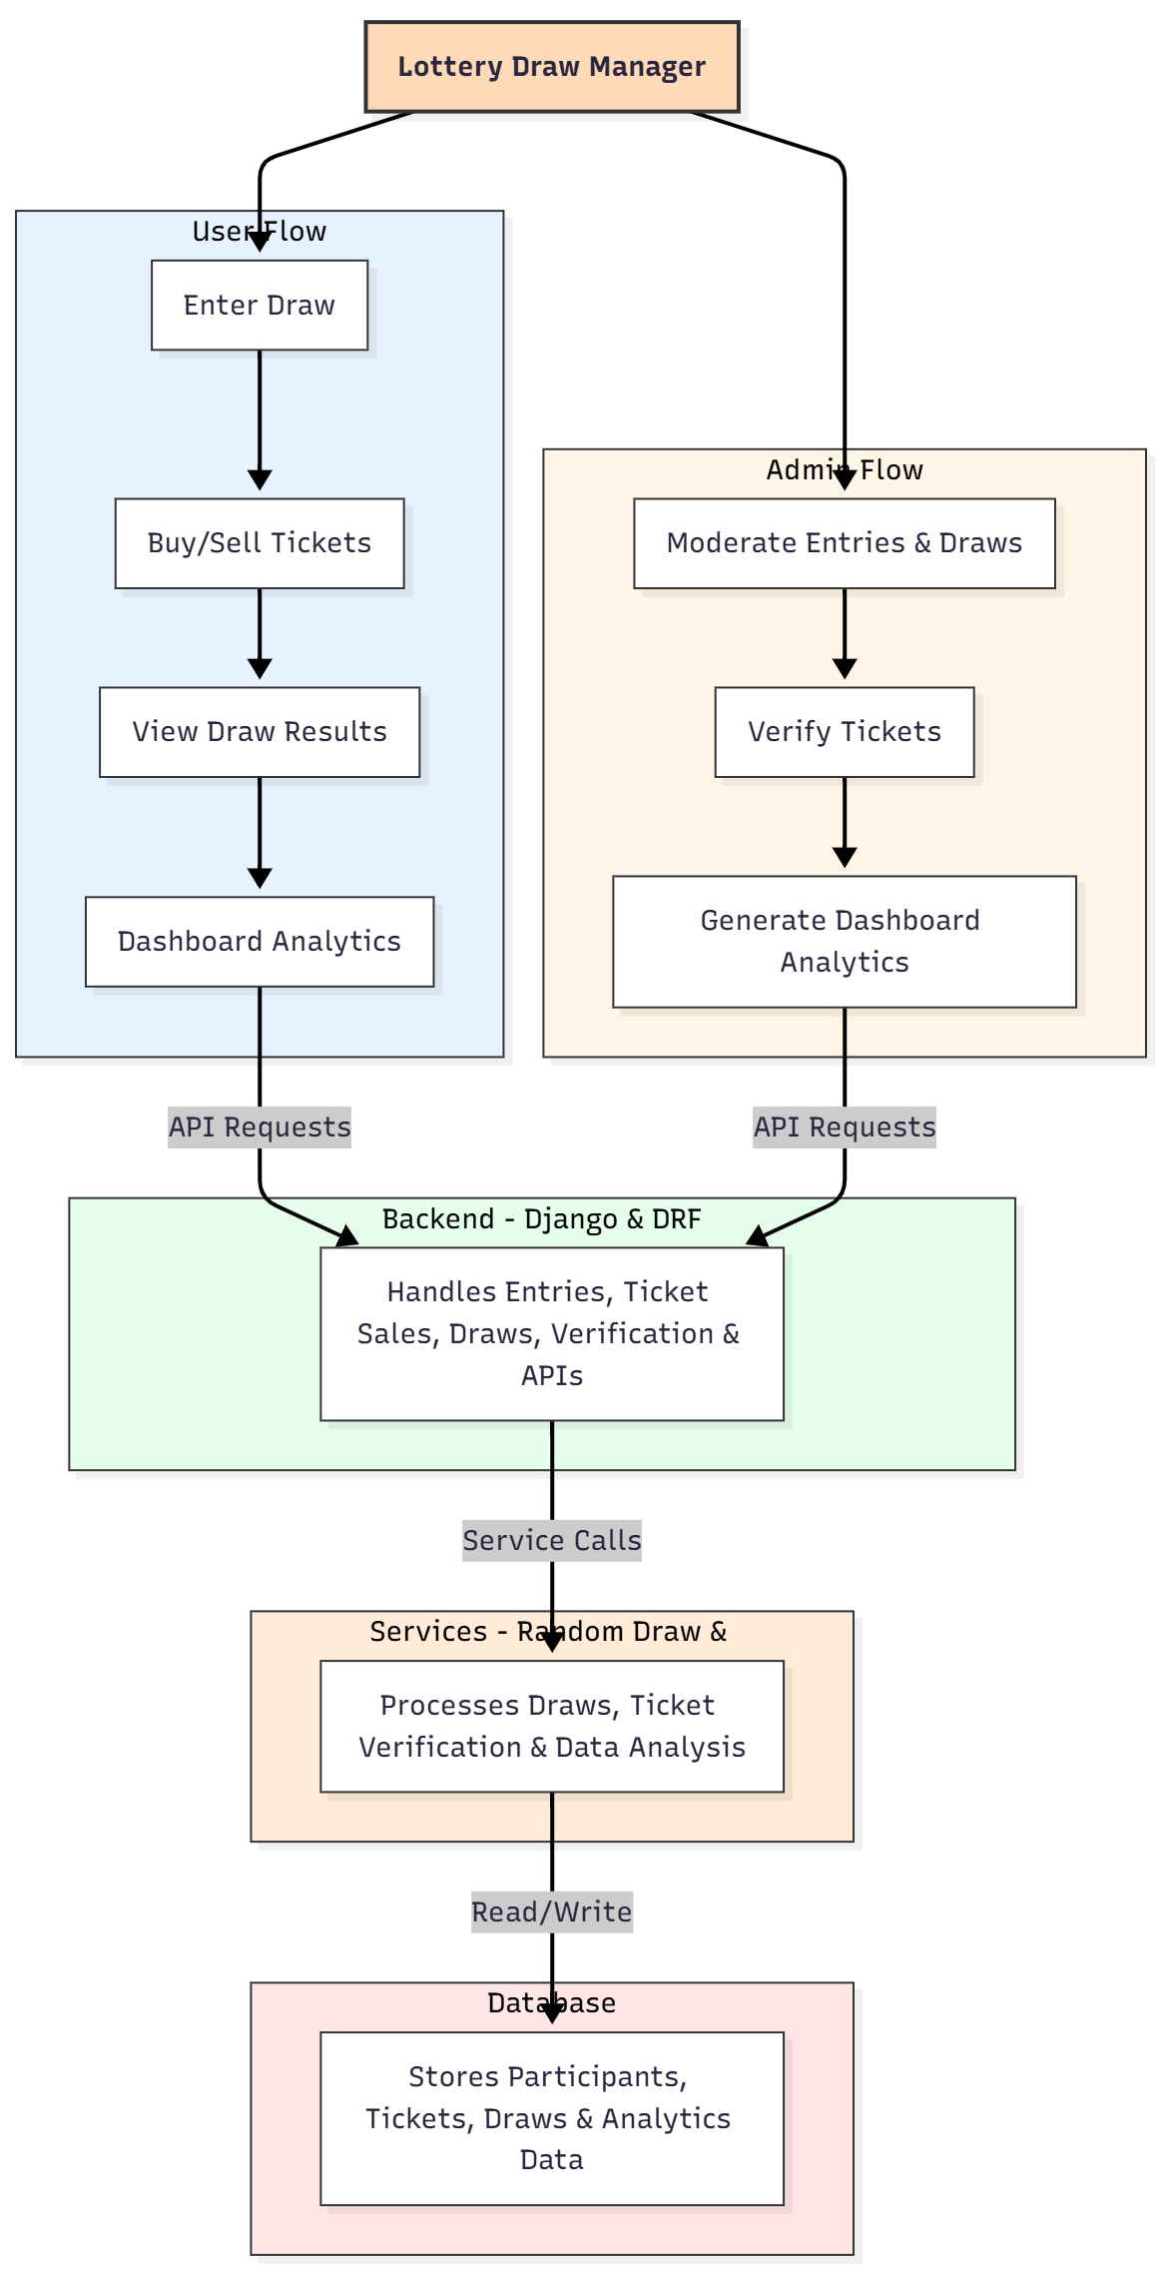

WORKING OF THE PROJECT:
Participants register and enter the lottery draw through the system, purchasing tickets online or via authorized sales. The backend validates entries, updates ticket availability, and records transactions securely. On draw day, the system conducts a random selection process, ensuring fairness. Results are published automatically for participants to view. Administrators monitor all entries, verify ticket authenticity, and track participant activity. Analytics services process sales, draws, and historical data to generate dashboards, providing insights for management. The database securely stores all participant, ticket, draw, and analytic information for transparency and traceability..

SOFTWARE REQUIREMENT:
- Backend:
  - Python 3.x
  - Django
  - Django REST Framework
  - SQLite/PostgreSQL
- Frontend:
  - Node.js and npm
  - React.js
  - Axios
- Development Tools:
  - Visual Studio Code
  - Postman (for testing APIs)
  - Git/GitHub (for version control)
- Server/Deployment (Optional):
  - Gunicorn, Nginx, or Heroku/AWS for hosting

ADVANTAGES OF THE PROJECT:

• Fully automated lottery draw management
• Secure participant entry and ticket tracking
• Transparent and fair random draw mechanism
• Real-time display of draw results
• Dashboard analytics for sales, participants, and draws
• Reduces manual errors and fraud
• Simplifies administration of lottery events
• Scalable for clubs, charities, and local fundraising initiatives

APPLICATIONS OF THE PROJECT:
• Clubs and social organizations
• Charity events and fundraisers
• Local community lotteries
• Schools and colleges for event-based draws
• Non-profit fundraising initiatives
• Internal corporate lotteries or giveaways

REFERENCES:

- Django REST Framework Documentation — Django Software Foundation. Django Documentation. Available: https://docs.djangoproject.com/
- Django REST Framework. DRF Documentation. Available: https://www.django-rest-framework.org/
- React. React Official Documentation. Available: https://reactjs.org/docs/getting-started.html
- Redux. Redux Documentation. Available: https://redux.js.org/introduction/getting-started
- PostgreSQL Global Development Group. PostgreSQL Documentation. Available: https://www.postgresql.org/docs/
- MySQL. MySQL Reference Manual. Available: https://dev.mysql.com/doc/
- Git. Git Documentation. Available: https://git-scm.com/doc
- Node.js. Node.js Documentation. Available: https://nodejs.org/en/docs/
- Axios. Axios Documentation. Available: https://axios-http.com/docs/intro
- Socket.io Documentation – https://socket.io/docs/

